Bookstore assignment

Technology Stack: - python 3.7,json,FASTAPI,Azure Cosmos DB(DB), request

Created Below List of API :-

1. Get books in db ":"http://127.0.0.1:8000/bookstore/bookdetails/{id},

(example- http://127.0.0.1:8000/bookstore/bookdetails/607c61cfeeaccff87b517330)",

2. Get all books in db ":"http://127.0.0.1:8000/bookstore/getallbooks/",

3. Get books based on count ":"http://127.0.0.1:8000/bookstore/page/{limit} ,

(example: - http://127.0.0.1:8000/bookstore/page/4)",

4. Add new book entry in db ":"http://127.0.0.1:8000/bookstore/addbook/",

5. Update books from ":"http://127.0.0.1:8000/bookstore/updatebook/{id} and add json in post body",

6. search books from ":"http://127.0.0.1:8000/bookstore/search/{search},

(example:- http://127.0.0.1:8000/bookstore/search/google)",

7. Delete books from ":"http://127.0.0.1:8000/bookstore/remove/{id}",

And For all api create consumer(client) code in client dir

Sample json for post and put call.

{

    "title": "Data structure",

    "author": "Devendra kumar Jha",

    "book_description": " Data structure algo. engineering",

    "added_time": 2021,

    "cost": 153

}

Note :- While Implementing search API ( "http://127.0.0.1:8000/bookstore/search/{search})

After some search, I found out that MongoDB provided on Azure (DOCUMENTDB...) does not support it.

Refrence <https://docs.microsoft.com/en-us/azure/documentdb/documentdb-indexing-policies>

My Implemented API Works fine using mongodb I tested in my locale to implement this I created text Index

db.book_collection.createIndex( { title: "text", author: "text"} )

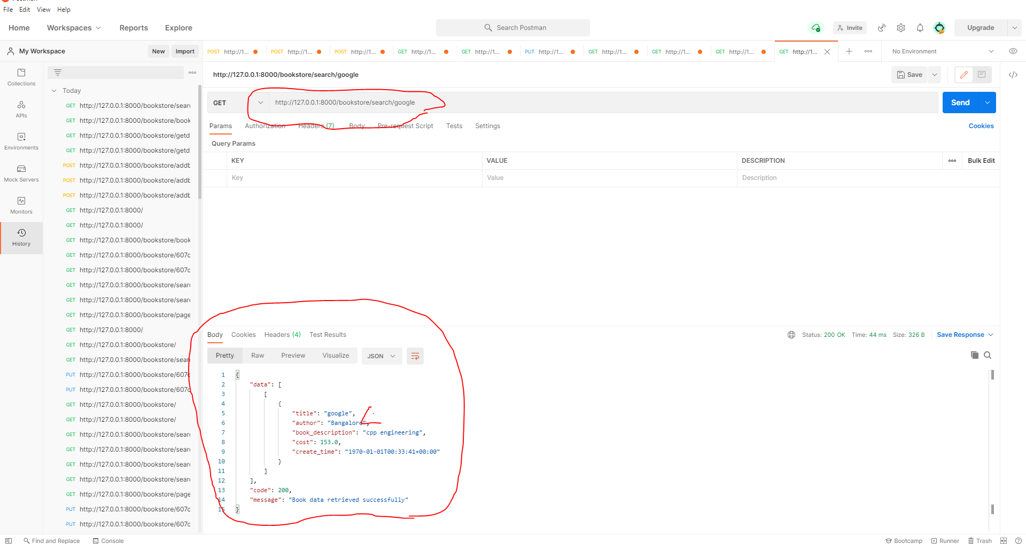

API Monitoring :-

For API Monitoring I have used **Jmeter .** using Jmeter I am sending 10 request and capturing matrix

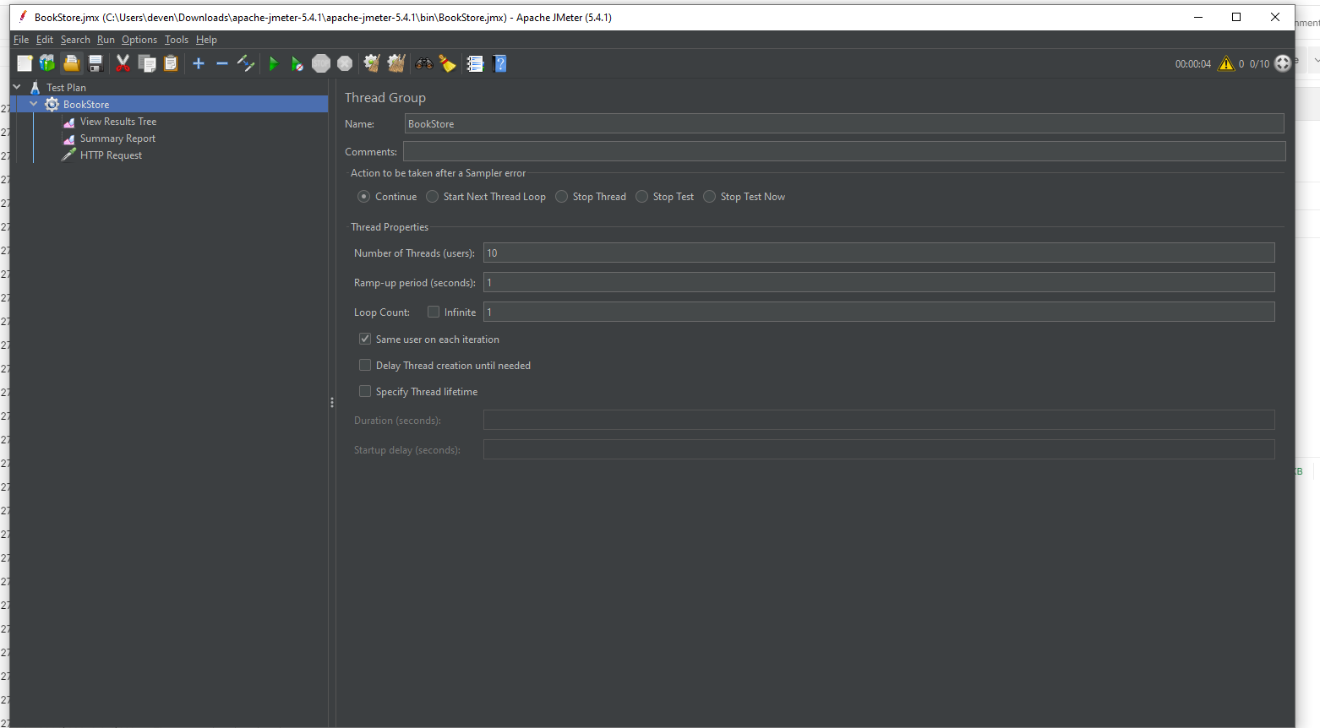

Cloud Usage overview: -

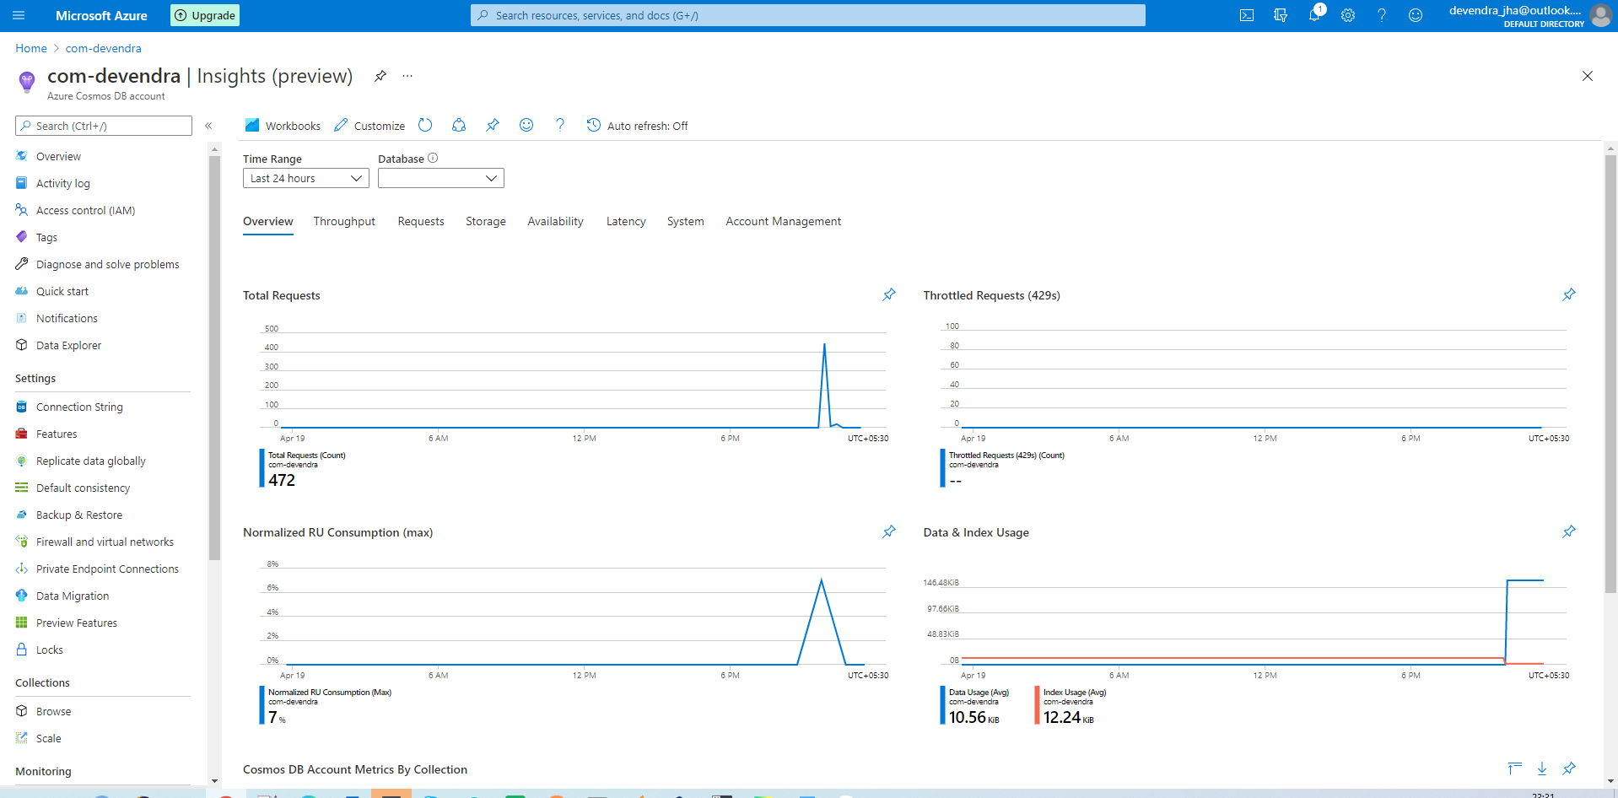

Requests

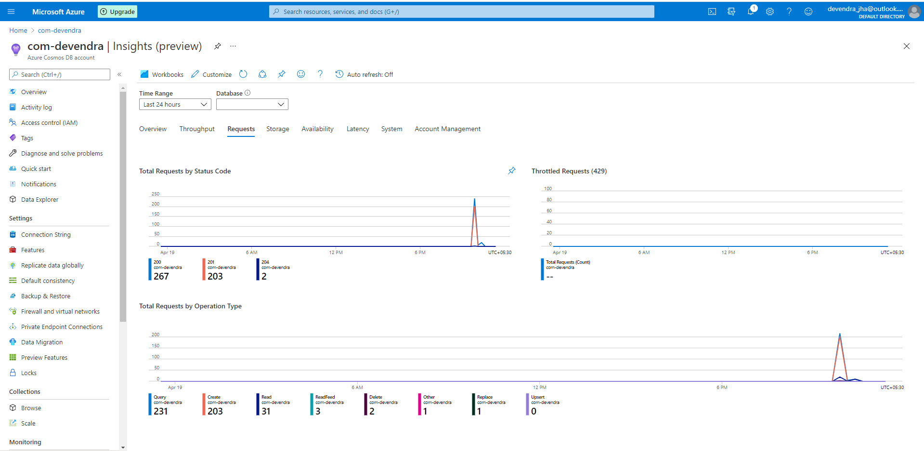

Server-side Latency: -

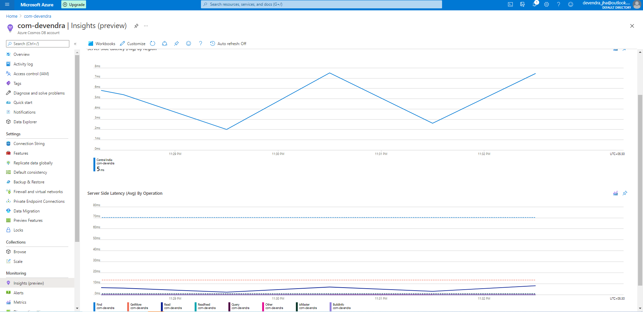

All Monitoring reports added in monitoring folder in project